


V-Mart

Experiential Learning
Business Challenge Analysis and Solution Development
Session 2025-26
Submitted By:
Yusuf Pipalrawanwala
Submitted To:
Dr. Ankur Kumar Rastogi

- Executive Summary -
- Combining the gradually increasing income with the significant operational constraints unveiled by the First Quarter of 2025 sales data and the two interactive Tableau dashboard outputs, V-Mart (three branches: Sapna Sangeeta -- Indore, Rajwada -- Indore, Freeganj -- Ujjain) is withstanding a penumbra of operational problems but is still confronting various operational challenges.

- The total amount of revenue in the three branches in the period under analysis is ₹322,967. The branch level performance is unequal: Branch C (Freeganj, Ujjain) is the highest earner ₹110,569). Branch A and B (Sapna Sangeeta and Rajwada) generate nearly the same yet lesser revenues (₹106,200-106,198 respectively).
- Product-line performance is also biased: Food & Beverages, Sports and Travel, Home and Lifestyle and Fashion Accessories demonstrate good results, whereas Health and Beauty continue showing poor performance (lowest sales per branch). The volatility of the daily sales shows steep peaks and declines with daily sales implying that the demand is not predictable and no demand-smoothing or promotion planning has been implemented.
- There is a mix of Balanced payment methods Cash, Online and credit card, which has a wide payment acceptance. With some internship learning (Smartbridge -- Tableau, data cleaning, KPI design, dashboard interactivity) knowledge Central business problem as suboptimal product assortment and demand management is discovered (resulting in underperforming categories, and revenue variability), which are worsened by inconsistent promotions and suboptimal local merchandising.
- Proposed solutions: Product-assortment/pricing optimization of low-performing segments (Health and Beauty). Localised merchandising and demand-smoothing promotions through interactive dashboards. Increase store level operations on POS & payment insights. All solutions will consist of cost-feasibility, anticipated results and implementation roadmap (short-term and long-term).
- The dashboards are interactive with decision-support (filtering, drill-down, what-if scenarios) - a sample scenario shows how a manager can filter to provide a promotional A/B test to Health and Beauty and monitor the results in near real-time. The end-stage suggestions focus on fast wins (promotional pilots and bundle offering) and intermediate investments (inventory and assortment optimization) to boost the category revenue and level-up the daily sales.
- Introduction to the Organization -
Organizational selected: V-Mart (supermarket chain); three branch locations were used in this research:
V-Mart is a local supermarket dealing with multi-category retailing (Food and Beverage, Home and Lifestyle, Fashion Accessories, Health and Beauty, Electronic Accessories, Sports and Travel). The three branches cover neighbouring urban catchments (students, families, working professionals). Positioning is value + convenience - competitive pricing and combination of necessary groceries and non-needed categories. It is discussing sales by the first quarter of 2025 (cleaned with skills acquired during the Smartbridge data-analytics internship and processed to become Tableau-friendly). Product line contribution, branch comparisons, payment models, daily trends, highlighted tables are found in the generated dashboards as multi-view analytics.


- Problem Identification & Analysis –
2.1. Evidence-based results (data) -
The most crucial indicators of your dashboards and report:
- Aggregate sale (Q1 2025) = ₹322,967 (dataset aggregate).
- Branch revenue: Branch C [= Freeganj] ₹ ₹110,569
Branch A ₹ ₹106,200
Branch B ₹ ₹106,198.
- Best product lines: Food and Beverages (₹56,145) and Sports and Travel (₹55,133).
- Worst-selling product line: Health and Beauty (lowest sales assuming overall, and lowest sales assuming per-branch e.g. Branch A: ₹12,598).
- Daily sales: The volatility is high and highest on some days of ₹7,000 and lowest at ₹1,500, (troughs and peaks are shown on the area / line graphs).
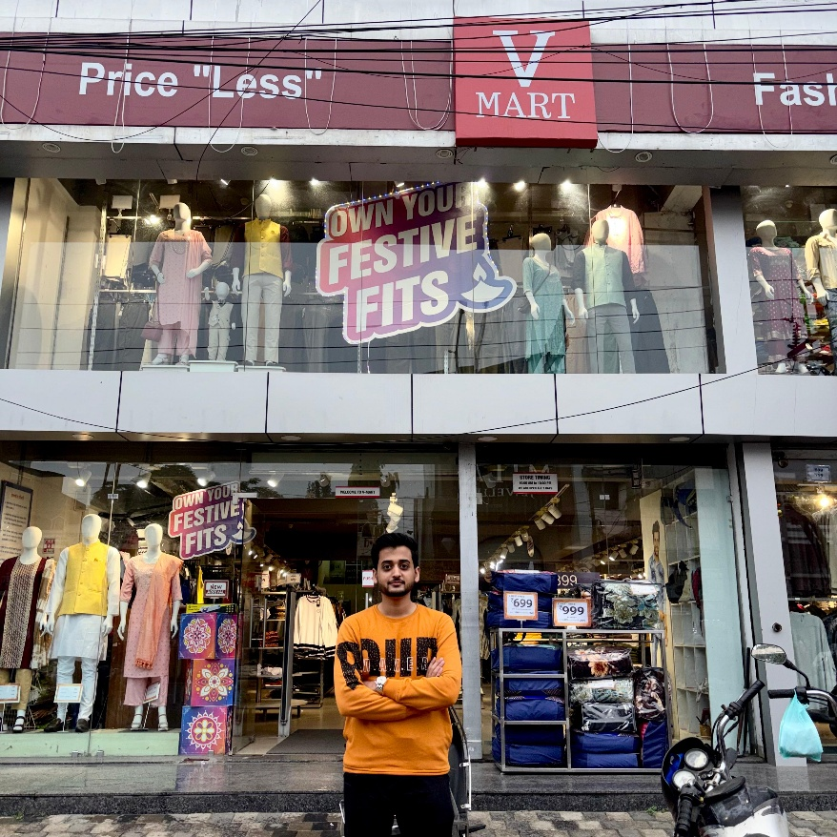

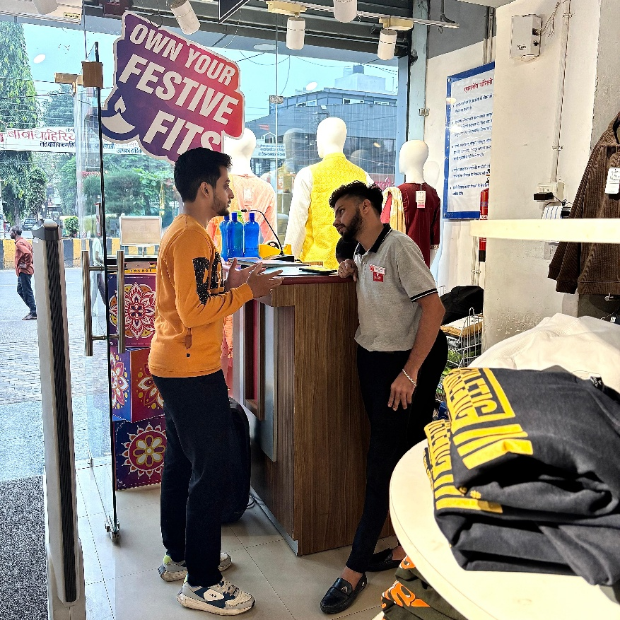

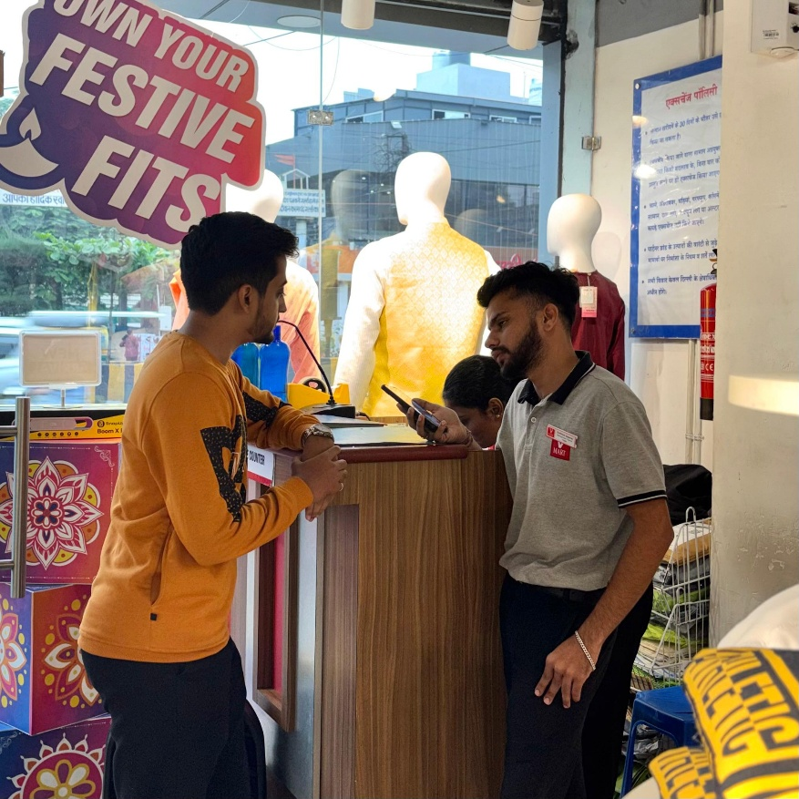

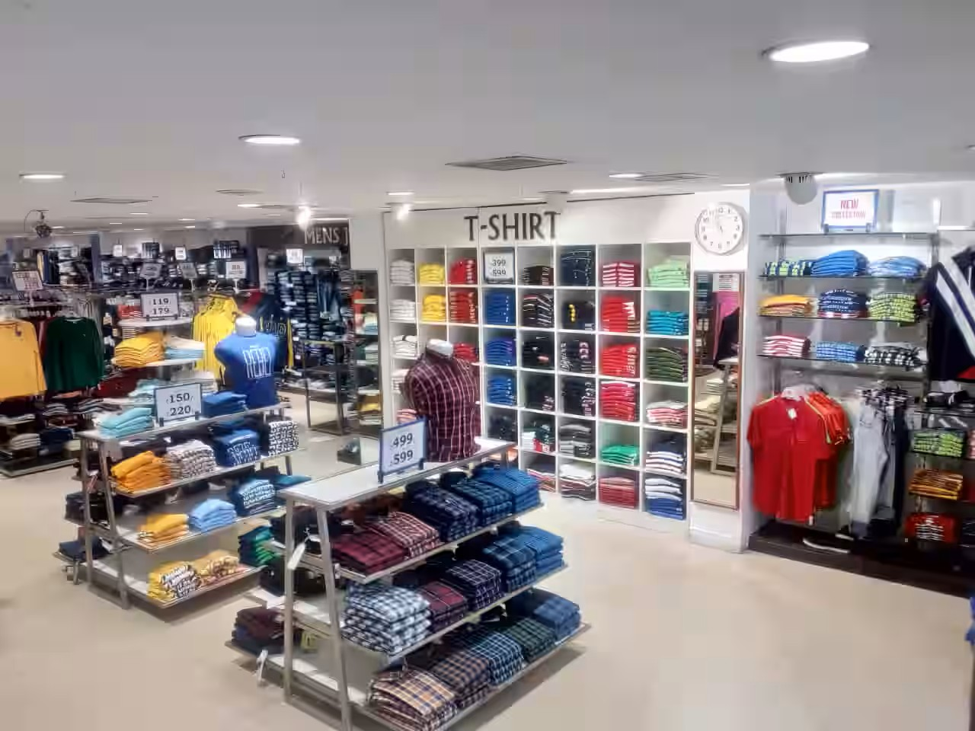

- Data Analytics and Visualisation -
- The analysis of the sales data with the development of different charts is the major goal to discover the information regarding product performance, sales rates on the branch, payment, and general contribution to the total income. To understand the various aspects of the operations of the V-Mart, the visualizations are used to investigate the operations of the company, the Bar Chart, the Pie Chart, the Stacked Bar Chart, the Line Chart and the Bubble chart waterfall chart, the highlight table, the area chart, the word cloud, the funnel chart and the bar chart.

- Two interactive, detailed dashboards developed in Tableau are also provided in this report. This was aimed at interpreting past sales records of a supermarket company and summarizing the most important findings in the form of an interactive dashboard. The three branches are covered over a period of three months.

- The pages below present images of the visualizations and dashboards, which combine different charts to present a multi-dimensional visualization of the sales performance, product line contributions, customer behaviour, and sales trends.

1. V – Mart Sales Data Excel File - V - Mart Sales Data.xlsx
2. Tableau Public Link to download the workbook and review - https://public.tableau.com/views/BusinessChallengeAnalysisandSolutionDevelopment/Dashboard1?:language=en-US&publish=yes&:sid=&:redirect=auth&:display_count=n&:origin=viz_share_link

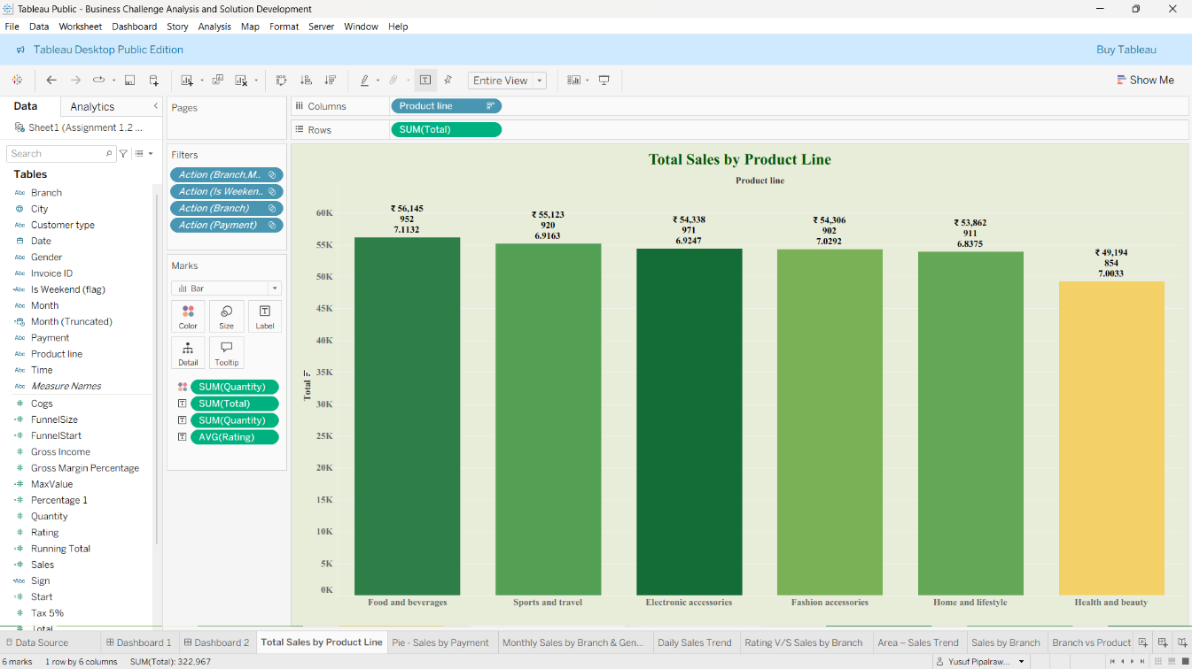
- Bar Chart - Total Sales by Product Line –

Chart Explanation - This bar chart can be used to show the number of sales produced by every line of products. This is because the vertical axis is used to depict the overall sales level, whereas the horizontal axis provided the various types of products being sold. Through the visualization, we can see that Food and beverages is the best performing section with sales of ₹56,145. The lowest sales were in the category of the health and beauty (₹49,194). This chart is explicit in comparing the performance of sales in the different product lines that the supermarket deals in.

- Pie Chart - Sales by Payment Method –

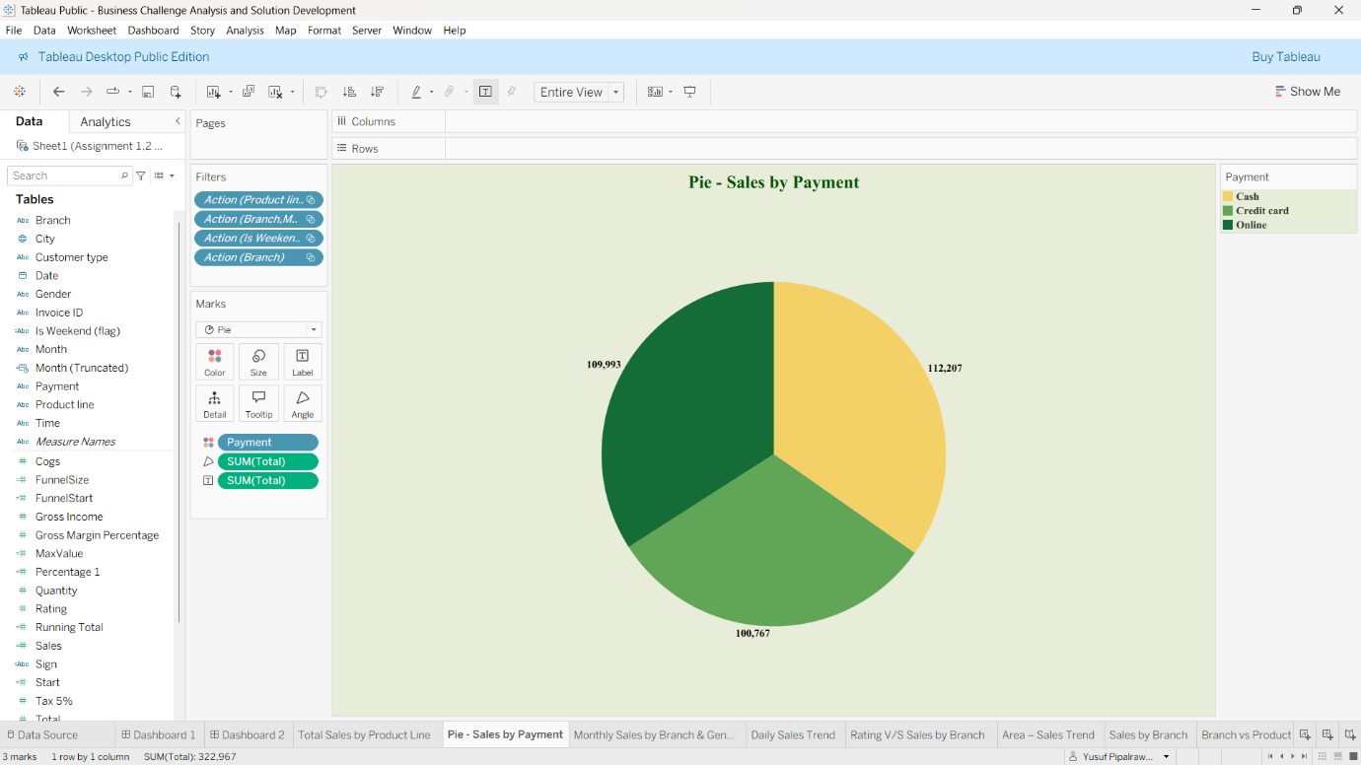
Explanation of Chart - This pie chart shows the distribution of total sales in various methods of payment. The three segments are the payment methods that can be used: Cash, Credit card and online. Each slice is the total amount of sales in each type of payment. The best way to make payments is online, where the sales amount to ₹112, 207. Then, comes Cash ₹109,993 and then Credit card according to the payments is ₹100,767. This shows that customers prefer modes of payment that are non-physical.

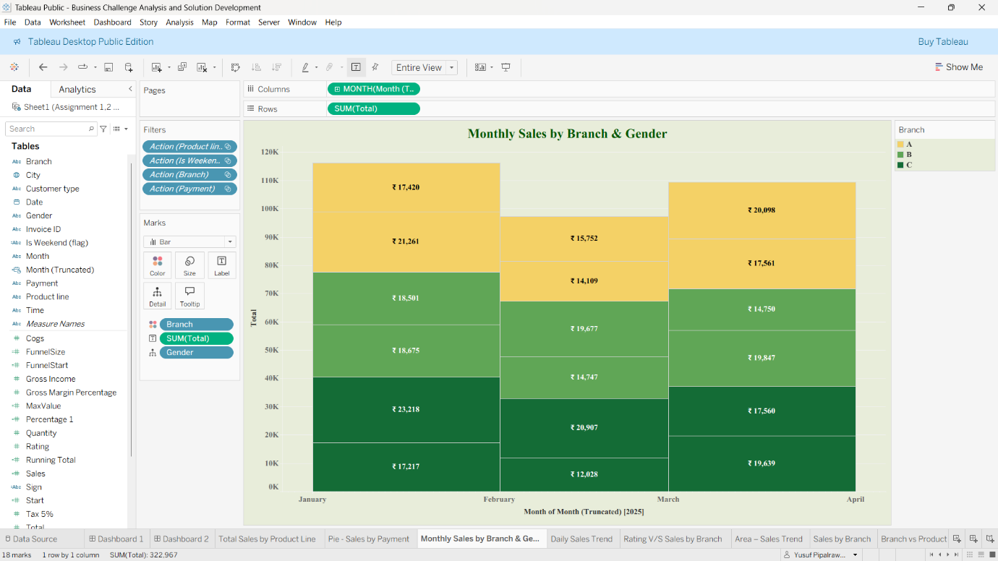
- Stacked Bar Chart - Monthly Sales by City & Gender –

Explanation of Graph - This stacked bar graph depicts an individual distinction of monthly sales based on the city and gender. The primary bars will mark the months of the first quarter of 2025. These parts in every bar are colour-codified according to city and location (Rajwada, Sapna Sangeeta, Freeganj) and further indicated with sales numbers per gender. Considering the case of January 2025 (2025-01), the total sales were maximum, influenced largely by the sales in Rajwada (Indore). This visualization could be analysed in multi-layers, not only about the month that was the most profitable or not, but also which cities and gender of the customers brought the greatest number of sales during this month.

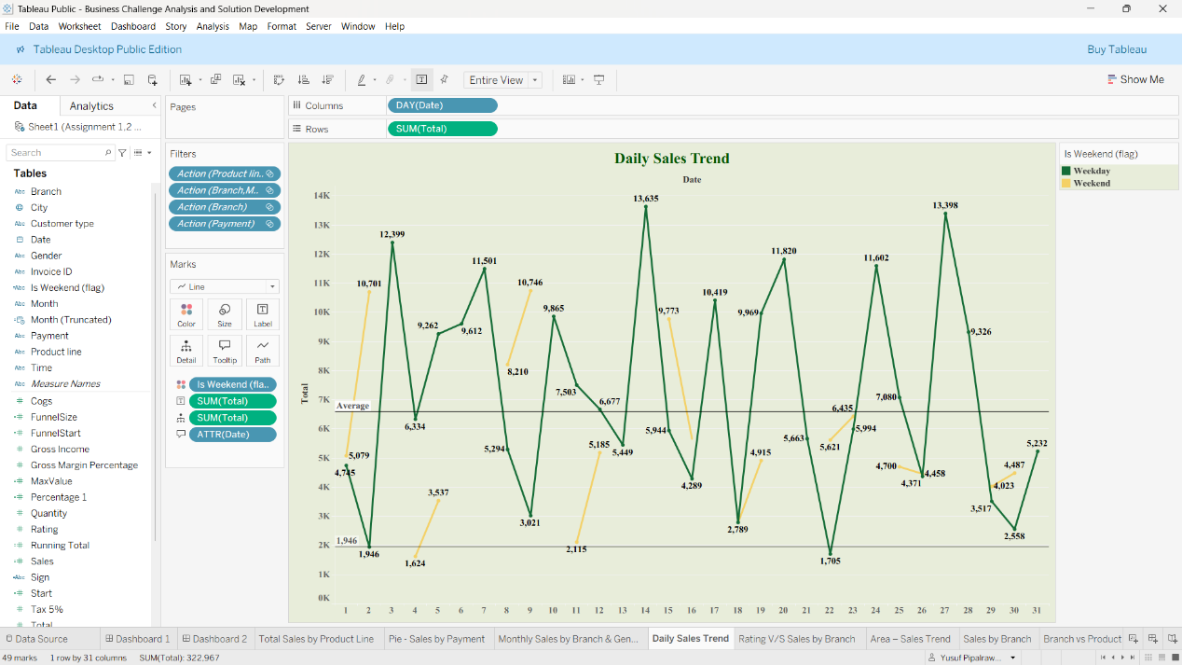
- Line Chart - Daily Sales Trend –

Chart Explanation This line chart illustrates the daily sales trend within a month indicating how there will be a variation in overall sales daily. The total sales amount is presented on the vertical axis and the days of the month on the horizontal axis. The chart warrants colour to indicate weekdays (blue) and weekends (orange). Daily sales vary very much, and there is a big season of ₹15,717 around the 13th of the month. This chart works well when searching patterns like a possible sale peak on given days or variation in sale performances between weekdays and weekends.

- Bubble Chart - Rating V/S Sales by City –
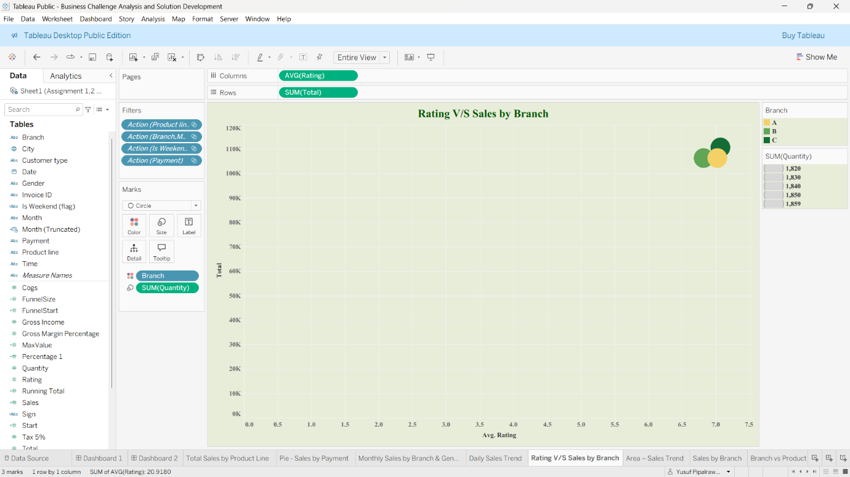

Chart Explanation This bubble chart is needed to draw the relation between average customer rating and total sales based on the city. The mean rating of customers (between 1 and 10) is the horizontal axis, and total sales are the vertical axis. Every bubble is represented by a city, and its area shows the total number of items sold.

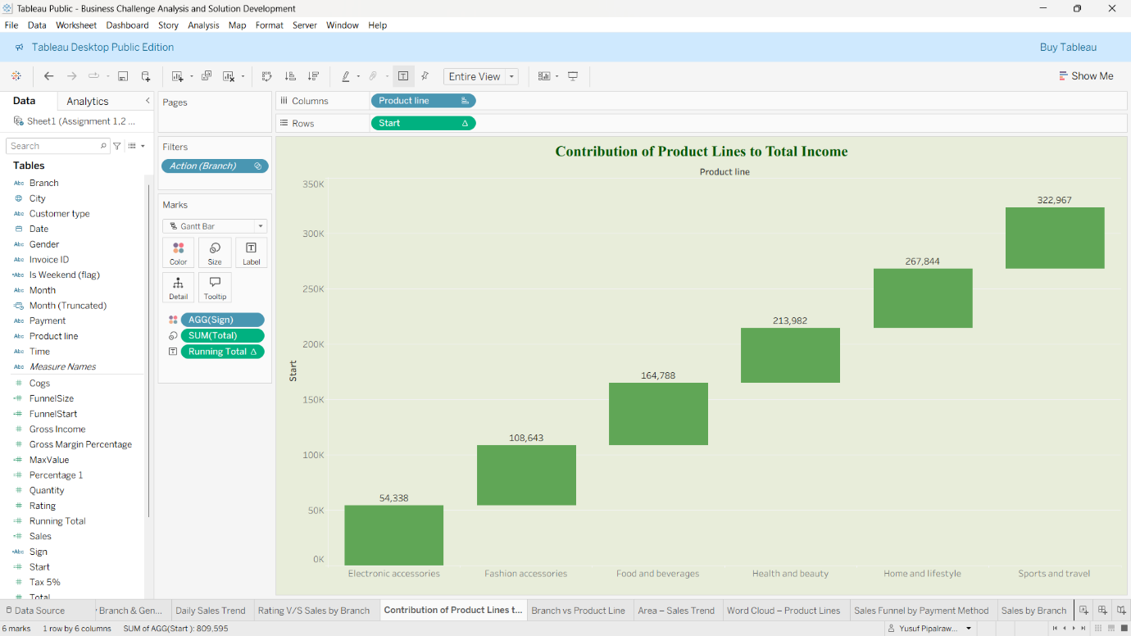
- Waterfall Chart: Contribution of Product Lines to Total Income –

Analysis - This waterfall chart will show how individual lines of products contribute towards the total income. It begins by analysing electronic accessories, which brought in an income of ₹54,338. The contribution to the cumulative sum made by each successive line of products is respectively, so that the total contribution made by all the products in terms of income will be that of objects, by Sports and travel. This chart is useful in demonstrating how the revenue on the various product lines sold by the supermarket has accumulated.

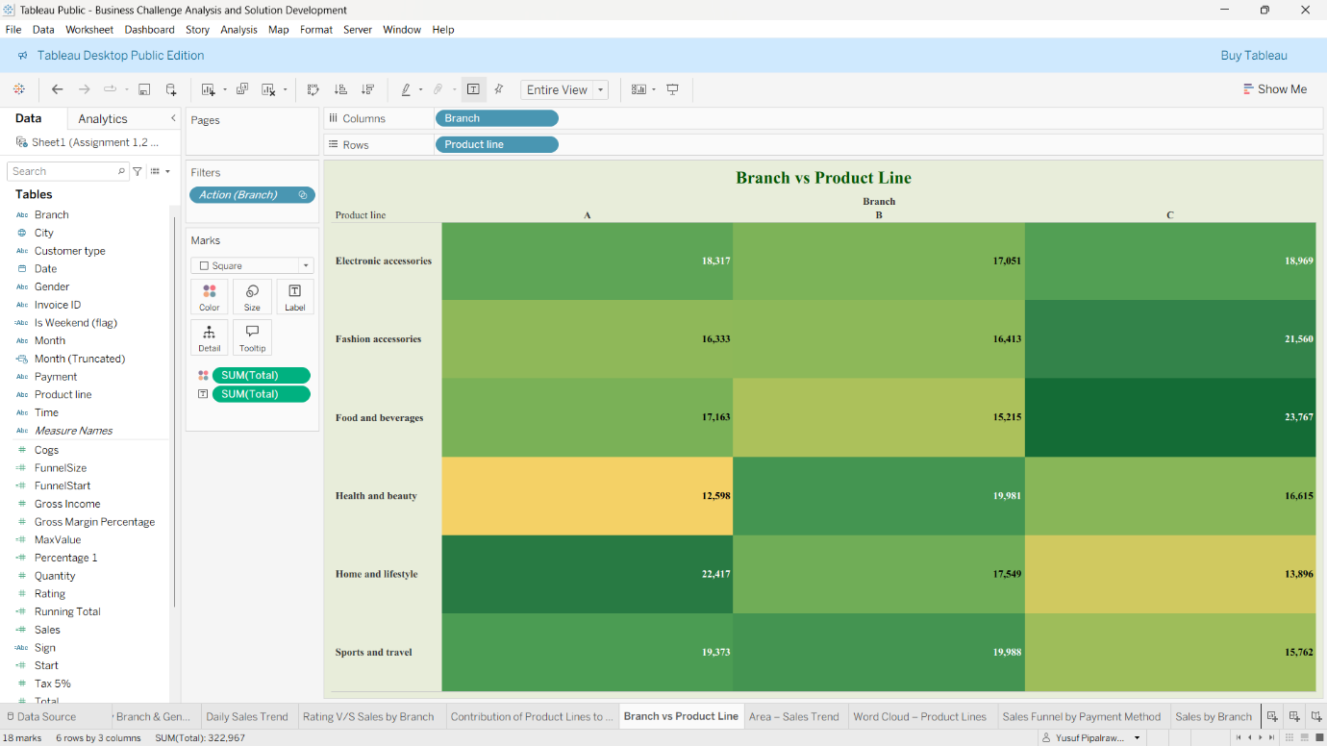
- Highlight Table: Branch vs. Product Line Sales –

Analysis - The breakdown of the totals sales of each product line in the three different branches A, B, and C is as is shown in this highlight table. The intensity of the colour is also proportional to the sales price which allows identification of the high-performing and the poor performing regions easily. Top Performers: Branch C made the most sales under the food and beverages category (₹23,767), and then the Branch A with Under the Home and lifestyle category being close behind (₹22,417). Worst Performing: Branch A's combination of the health and beauty products achieved the lowest sales as at \₹12,598.

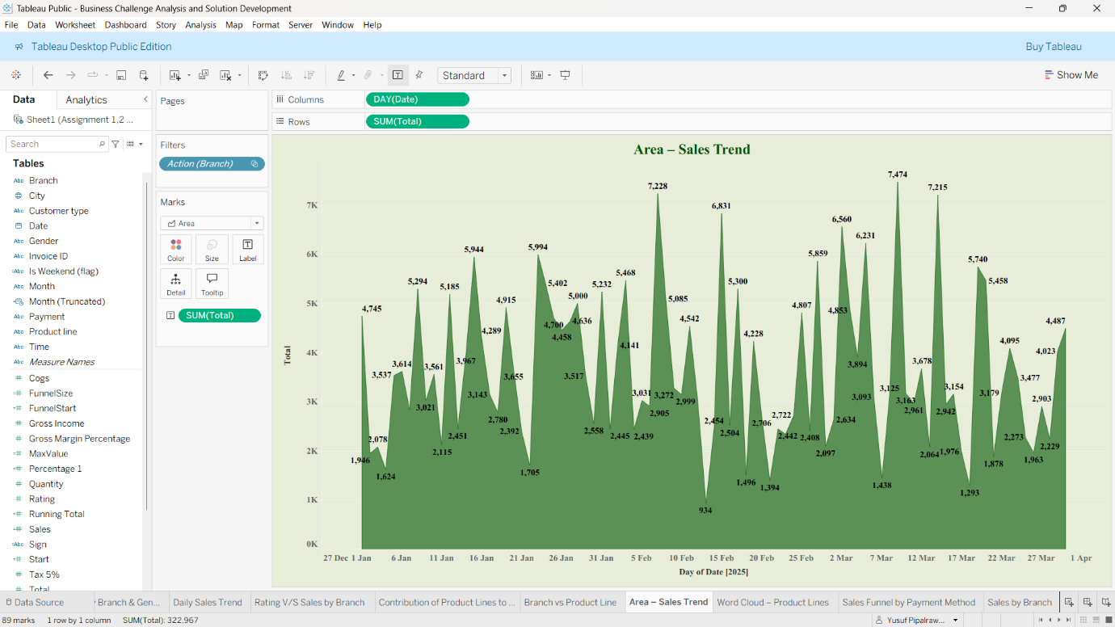
- Area Chart: Sales Trend Analysis –

Analysis- This is an area chart that illustrates the trend of the daily sales during the three months of the year 2025 in the month of January to March. The figure shows that there is great volatility in daily sales revenue. These are individual peaks and the sales are over \₹7,000 on days in mid-February and mid-March that show a high activity of the customers. On the contrary, some sharp declines are also present as the sales are much lower than \₹1,500 on some occasions, which shows how the daily income of the supermarket could vary.

- Word Cloud: Product Line Sales Volume

Analysis - This word cloud draws performance of various product lines, and the size of the name of each product line can be compared to the total sales revenue of this product line. According to the visual representation: Major Contributors: The largest contributors are "Home and lifestyle" and "Fashion accessories" which indicate that they are the leading contributors to total sales. Other Categories: Other Categories that constitute large shares of the sales are; "Food and beverages; Sports and travel; and Electronic accessories. It has the lowest cumulative sales of the products, implying that the size of it is the smallest.

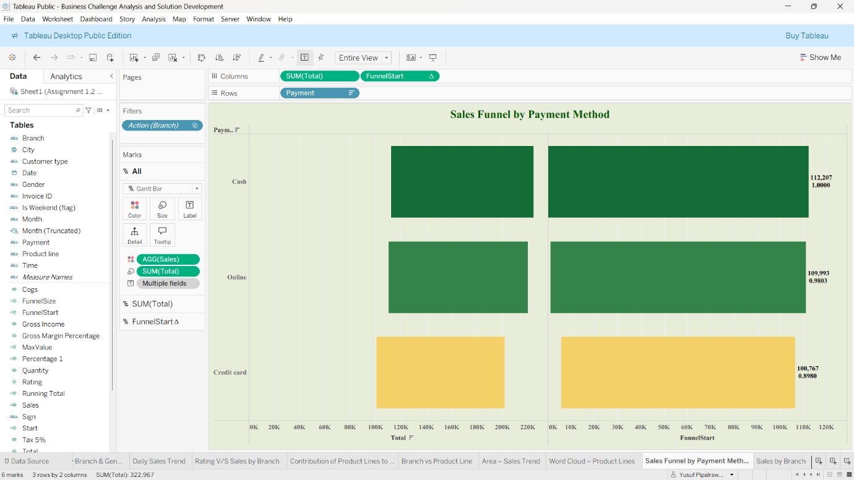
- Funnel Chart: Sales by Payment Method –

Analysis - This chart analyses the preferences of customers to pay in terms of the total sales made using each of the payment options available: Cash, Online, and Credit card. The visualization suggests that the portion of sales disposes rather evenly of all the three payment methods which are popular among customers:
Cash: \₹112,207
Online: \₹109,993
Credit Card: \₹100,767
This implies that having variation in payment methods is good in order to accommodate various shopping habits.

- Bar Chart: Total Quantity Sold and Sales by Branch –
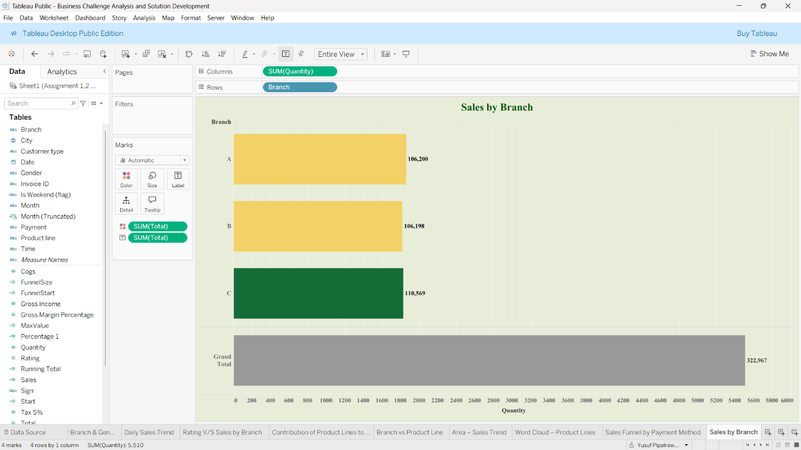
Analysis - This bar chart is the comparison of performance of the three branches of supermarket. The numbers of the bars will be the total number of items sold, and the labels will show the total sale revenue per branch. Branch C: Is the best-performing branch, selling the most products and bringing the largest revenues at ₹110,569.
Branch A and B: Resemble in performance greatly. Branch A was marginally ahead of Branch B in the amount of goods sold, as well as revenue generated, at ₹106,200 versus ₹106,198. The total sales in all branches are:₹322,967.

- Dashboard – 1
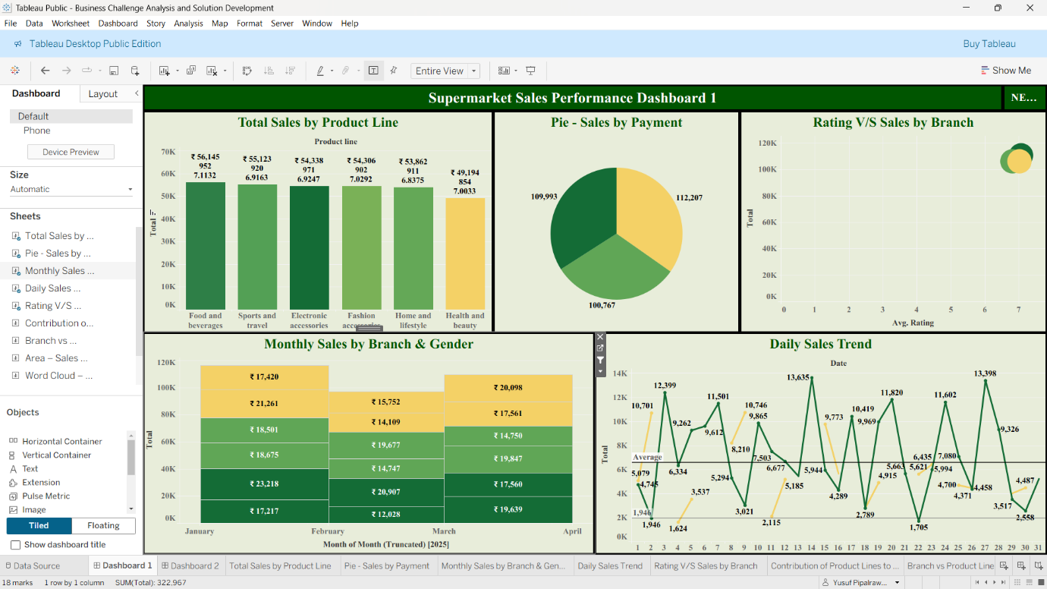
- The Product Lines Contributions to the Total Income: A waterfall chart on the upper left indicates the way the total income of ₹322,967 is constructed step-by-step according to the sales made by every product line.
- Area - Sales Trend: Area chart in the top-centre visualises the changes in the daily sales between the end of December and the month of March and indicates the peaks and downturns in the revenues.
- Branch sales by Branch: The bar chart on the right-hand side measures the performance of the three branches, and it shows Branch C has the largest sales revenue (₹110,569).
- Branch vs Product Line: The Table of highlight on the bottom-left provides a vivid breakdown of the sales per line of each product per branch.
- Sales by Such Method of payment: This funnel chart provides the sales of the three methods of payment: Cash, Online and Credit Card.
- Word Cloud - Product Lines: This word cloud on the bottom-right displays the level of sales of each line of products, the size of the font represents the magnitude of the revenue made.

- Dashboard – 2
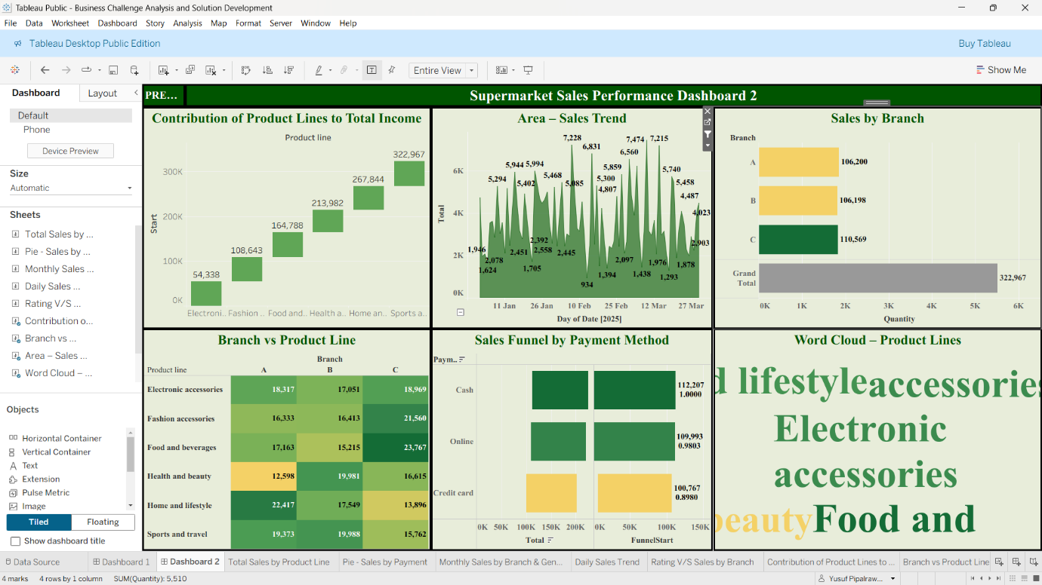
The second dashboard allows having a different perspective on the performance indicators of the supermarket, i.e. regarding product lines, payment methods, and monthly trends.
Total Sales by Product Line: The bar chart at the top-left ranks product lines in terms of total sales with the two highest rankings being "Food and beverages" (₹ 56,145) and Sports and travel (₹ 55,133).
Pie - Sales by Payment: A pie chart on top-centre shows the percentage of sales made by each method of payment, the biggest chunk being Cash ₹112,207).
Branch vs Sales V/S Sales: This chart will help to plot the average rating of customers per branch versus the total sales.
Monthly Sales by Branch and Gender: This bottom-left bar chart is subdivided by the total January sales, February sales and March Sales. The monthly bars are further divided to represent the contribution of each branch and coded by gender, and this gives a striking quality in displaying the sales demographics over time.
Trend in the Sales: Daily Sales Within the bottom-right, the line chart shows the daily sales trend, and with its help, one can identify the days with high and low revenues easily across the course of the quarter.
2.2. Key business issue (diagnosis) -
- Upon examining the dashboards, the main issue regarding V-Mart is that it has an ineffective product assortment and demand control and it presents itself as: Poor performance of Health & Beauty in all branches (low in terms of revenue relative to other classes).
- Intra-period volatility of daily sales so high that the demand is not consistent, or the company has no effective promotions/planned events, or the assortments do not align with the local buying patterns.
- Poor performance of one branch slightly ahead of the others of the company which indicates that merchandising and operation can be well localized and specific improvements adopted.

2.3. Framework-based root-cause analysis -
- SWOT (oriented to the problem noted) -
- Strengths: Multi-category store, equal payment facilities, clean sales data and dashboards (decision analytics capability).
- Weaknesses: Underperforming Health and Beauty segment; ineffective promotions; no apparent localization assortment decisions.
- Opportunities: A/B promotions: Confront rivalry through interactive dashboards; Assortment and pricing: Optimize demand through interactive dashboards; Loyalty program: Flatten demand through loyalty programs.
- Threats: Local competitors that have a better selection of Health and Beauty; competitor pricing at the cost of margins.

- Porters Five Forces (affecting product-line performance) -
- Risks of substitution: Health and Beauty: high (numerous one-purpose stores and online).
- Buyer bargaining: Rigorous among price-sensitive buyers- promotions count.
- Competitive rivalry: Cutthroat at a neighborhood level with respect to discretionary classes.
- Supplier power: Depends on category, greater with niche personal-care brands.
- Potential new entrants: Medium (low capital to small-format stores or specialized kiosk).

2.4. Evidence of impact -
- Lost opportunity revenue in Health and Beauty: Because Health and Beauty is lowest selling branch to branches, the category has a smaller share in total basket value and margins.
- Operational inefficiency: Sales volatility renders workforce scheduling, inventory planning and promotional planning inefficient such that it increases the operating costs, generates stockouts/overstocks on alternative days.

3. Application of Internship Learning (Smartbridge Data Analytics - Tableau) -
Through the internship at Smartbridge skills in data-cleaning were acquired, KPI design, exploration, and interactivity (Tableau). This exactly is applicable:
- Data preparation and data cleaning - You already made use of the ETL tasks (filtering, sorting, other operations, removing duplicates, formatting dates) to create a clean dataset to use in analysis and dashboarding. This provides reliable measures that are employed in the report. Data: cleaned version of data on files, Tableau workbook. <|human|> Evidence: (cleaned information: controlled data on files and Tableau workbook).
- KPI choice and computation - Targeting business actions with KPI, you may use KPI, including Total Sales, Average Basket Value, Sales by Product Line, Sales by Branch, and Daily Trends. As an illustration, Average Basket (Sales / Transactions) sends information about bundle deals on Health and Beauty.
- Interactive dashboard / filters - The live dashboards enable managers to drill all the way down by branch, date, form of payment or product line to make custom operational decisions (e.g., which stores should get more stock Health and Beauty stock to make a promotion). These capabilities are evidenced in the dashboards in your workbook.

- A/B testing / measurement strategy - Every aspect of promotion experimental measurement and incremental lift measurement are achievable by the ability to gauge daily sales together with the ability to filter the segmentation of sales.
- Visual presentation of stories - You already built multi-view dashboards (waterfall, highlight table, area chart) this assists in getting the root causes to the stakeholders and acquire buy-in to interventions.

Rationale of relevancy: These abilities are the core of data-driven and low levels of risk (promotional pilots, localized assortment adjustments) changes, but these are not highly capital-intensive.

4. Proposed Solutions -
Background-- solution priorities
- Quick wins (short-term): Targeted promotions based on dashboard; promotional pilots and bundling of Health & Beauty.
- Operational modifications (mid-term): optimized assortment, redistribution of inventory among branches, better planogram Health and Beauty.
- Capability investments (long-term): Tests of the loyalty program and dynamic prices; Tests predictive daily demand model and automated reorder triggers.

- Solution 1 - Assortment-Promotional Optimization (Main) and Targeted Product.
- What: 6-week pilot to boost Health and beauty sales by using target in-store promotions (bundles, discounts, endcap placement), moving products on and off branches (sell best-seller in poorly performing stores), and electronic coupons through e-wallet dealings.
- Reason: Health and Beauty category performs poorly yet can be made to enjoy high margins; small pilots are used to test demand and require little investment. Lift can be easily measured using interactive dashboards.

- Actions (Short-term 0-8 weeks):
- Find SKUs selling best in branches in the Health & Beauty category. (See highlight Table and product-line charts).
- Branch A (Sapna Sangeeta): (A) Health and Beauty + Food item Promotional bundle discounts vs (B) Control (no promo). Compare daily sales uplift using dashboard filters.
- Redistribute Branch C (strong performer) Health & Beauty SKUs with 10-15 percent of best sellers to Branch A to pilot.
- Push via Ewallet partner a digital coupon that can be redeemed in Branch A (utilizing payment mix).
Costs & Feasibility: Low to pleasing Costs discount cost and marketing (posters, digital coupon). Minor logistics are needed to transfer stocks. Very practical to be carried out now. Predicted results: 10-25% increase of Health and Beauty turnover in pilot branch; the lessons to be replicated in other branches. Higher personalized shops.

- Solution 2 - Demand-Smoothing Promotions and Workforce/ Inventory Alignment.
- What: Based on dashboard-generated daily sales patterns, plan weekday promotions (low sales days), and weekend high-end offers as a way of levelling the volatility and enhancing resource planning.
- Reason: Operational cost (overstaffing (low days), stockouts (peaks)) is high with change in sales every day. Demand-smoothing eliminates overheads and enhances customer experience.

- Actions (Short-term 4-12 weeks):
- Evaluate heatmap by the day and determine days with low sales. (Make a calendar heatmap using daily sales in dashboards).
- Implement Weekday Saver promo (discount, package) which is promoted via the Ewallet push promote notification and on-store promoted signs on selected low-selling days.
- Change the staffing schedules and deliveries to the expected demand after the plan of promotion.
Costs, Feasibility: Low; channel messaging and promotional discounts. Easily within no time- coordination with store managers.
The results to be expected include - Decrease in the variance of sales on a weekly basis; enhancement in staff scheduling; better turnover of the stock.

- Solution 3 Localised Merchandising and Inventory Optimization (long term)
- What: Re-planograms Designed, branch specific assortment and reorder, based on consumption pattern simple predictive reorder, based on dashboards.
- Ration: Branch C has been performing well in local preferences. Local assortment ensures that each of the store’s stocks what is performing well.

- Actions (Mid-term 3-6 months):
- Create product affinity list based on the data of experience level ( What the customer buys with ) and transaction level.
- Use store planograms and signage in stores to create an illusion of the availability of bull items that would appear to be at a high demand in the location (e.g., Food and Beverages vs. Health and Beauty).
- Accept SKU reorder rates of historic demand negation of 4-6 weeks daily (safety implementation). Monitor the stock and lead-time with Tableau dashboards.

Cost expediency: medium of cost of varying inventory system and training employees. The suppliers can join hands with the firm to attain improved lead-times.
Wanted outcomes: Better availability of high demand SKUs, reducing the number of stockouts and over stocks will also become anticipated after 3-6 months and improving the category revenue.

5. Implementation Roadmap -
Phase 0 -- Preparation (Week 0-2)
- Full project team (you, store managers, merchandising head -data analyst).
- Data set/ measurements checking up (Total Sales, Quantity, Average Basket, Sales per SKU, Daily Sales).
- Form Product date Tableau filters.

Phase 1: Phase 1: Enrolment, Pilot Promotions-Dashboard-Deployment (Week 2-8):
- Branch A/B pilot layout (Health and Beauty).
- Place KPI tiles in Pilot Sales dashboard, Control Sales, Redemption rate, Inc Lift.
- Part 6 weeks; day by day monitoring with written dash. Interactive filters are offered which will entail pilot versus control comparisons (see figure above).

Phase 2 Demand-Smoothing Promotions Week 6-12.
- Weekend deals that will be concentrated in destinations whereby low-sales day in branches is determined.
- Change deliveries and manpower. The advantage is that the variance will be altered, and the amount of sales average per day will be measured with the assistance of dashboard.

Phase 3 Optimization of Inventory and Assortment (Month 3-6)
- Determine SKU level demand curves, add reorder point which is lead-time sensitive.
- A prepares fat work planograms and allocates the shelf space to the desires of the branch.

Phase 4 -- Scale & Automate (Month 6-12)
- Tradition of the winning experience to other branches.
- Start day and to take KSFs are always kept to the POS + Tableau.

Performance measures to be implemented: Increase sales uplift of Health and Beauty, average value of the basket, variance sales (standard deviation of daily Sales) stockout, redeeming rate of promotions.

6. Interactive Dashboard: Benefits and State -
Filterable interactive genres (some of which are now multifaceted and complex to implement) Branch filter, date range filter, product line filter, payment method filter, KPI templates (Total Sales, Average Basket), highline actions (Click a product line and filter all charts), tooltips with underlying counts and contribution convenience.

7. Conclusion and Recommendations.
Findings: The data and the dashboard show that the lack of optimal product assortment and control over demand is the primary failure of the situation that is expressed in the following way: the products of a uniform low result of the group in Health and Beauty and other changes of the daily sales.
And with that data cleaning and development of Key Performance Indicators and interactive dashboards expertise which were developed on Smartbridge internship (data cleaning, KPI design, interactive dashboards), we can execute cheap, massive impacts pilots and operations changes, on which to attempt and spin the dial.

The priority of recommendations (in order of the importance):
- Branch A ( Branch A 6-week pilot promotion of Health and beauty) Branch A Promotion Test lift and promote Health and Beauty pilot promotion with bundle coupon + Ewallet. (Immediate priority).

- Use demand smooth marketing weekly and day-to-day purchasing forecast just to minimize the sales and employee optimization.
- Branch level analytics on the dashboard will be used to establish the branch-based assortment and reordering policies (3-6 months plan).
- Promotions, monthly review of the assortments, Promotions, weekly review of 1 activity of Promotions, dashboard KPI, dashboard daily refresh are supposed to be simplified.

It is believed that through such intervention the scale of Health & Beauty sales, purchase size, reduction in the variance between days to days and increase of store level profitability will increase.

8. References -
1. V – Mart Sales Data Excel File - V - Mart Sales Data.xlsx
2. Tableau Public Link to download the workbook and review - https://public.tableau.com/views/BusinessChallengeAnalysisandSolutionDevelopment/Dashboard1?:language=en-US&publish=yes&:sid=&:redirect=auth&:display_count=n&:origin=viz_share_link

Davenport, T. H., & Harris, J. G. (2007). Competing on Analytics: The New Science of Winning. Harvard Business Review Press.
Tableau. Used for dashboard principles and KPI tiles.

Appendix (Already inscribed within the document)
- Appendix A — cleaned sample dataset summary have been added above
- Appendix B — screenshots and annotated dashboards highlighting pilot filters and KPI tiles.

